Proposal for Safety Pin Emoji
Submitted by: Amanda Hickman, Amberley Romo
Date: July 1, 2017

Abstract
We are requesting the addition of a SAFETY PIN emoji. Though the making, mending and wearing of textiles is a defining characteristic of human society the current emoji character set includes no sewing or textile related emoji.

Introduction
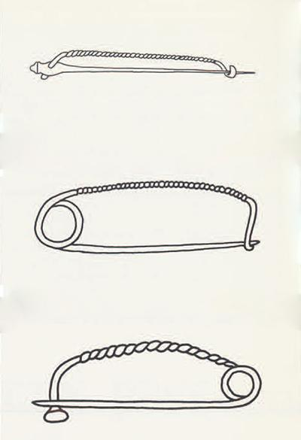
The SAFETY PIN is a simple yet ingenious invention, which practically everyone has used at some point. It is is a self-closing pin that is made from a single piece of wire, which is coiled into a spring at one end with a clasp and point at the other end. The clasp both holds the pin in place and protects users from the sharp point.

Though the emoji character set includes glyphs for a number of tools, such as the 🔨 🔧 and 🔩, there are no glyphs for the making, mending, or maintenance of textiles. Alongside the YARN, NEEDLE AND THREAD, and SPOOL OF THREAD proposals, this is one of a number of sewing and fiber arts proposals that fill a notable gap in the character set.

History: On April 10, 1849, Walter Hunt was granted US patent #6,281 for his safety pin. He called it as a "dress pin" but the design was unmistakably the safety pin we use today, with a single wire to form the whole pin, hinge and clasp. Hunt's invention was hardly new however: spring loaded clasps made of a single wire date back to ancient Greece and Rome. The Mycenaean fibula shown here is clearly a precursor to the modern safety pin.

The safety pin is so ubiquitous today that a single factory might turn out 30 million pins in a single week.

Though it has never been declared a formal holiday, a number of sources promote celebrating the anniversary of Walter Hunt's patent as International Safety Pin Day.

Names
(Suggested short name and keywords, as in the Emoji List).
- Safety pin
- Kilt pin | diaper pin | quilt pin

Images
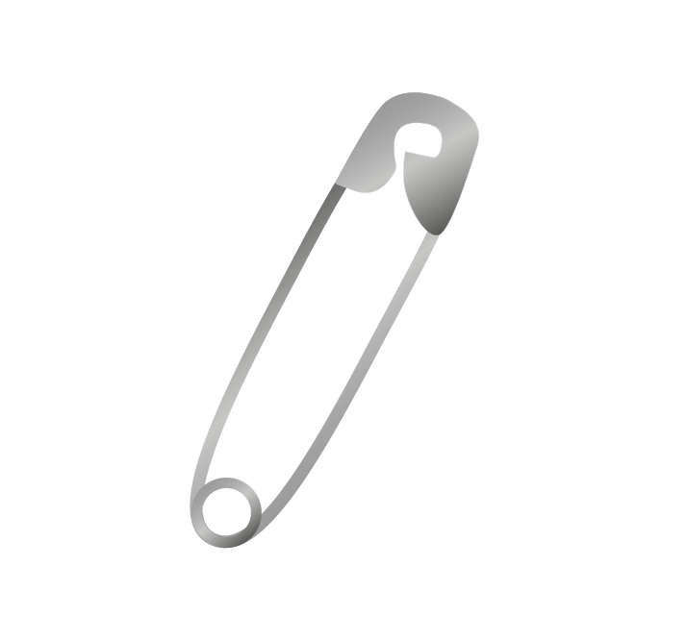
Artwork created by Cherin Sanih

Selection Factors Inclusion

A. Compatibility
We are not aware of a SAFETY PIN icon or emoji in an existing character set.

B. Expected Usage Level

1. Frequency
With the exception of a spike in the fall of 2016, when the safety pin emerged briefly as a symbol of anti-racist solidarity in the US and in the UK, the safety pin has remained consistent with the thumbtack and paperclip:
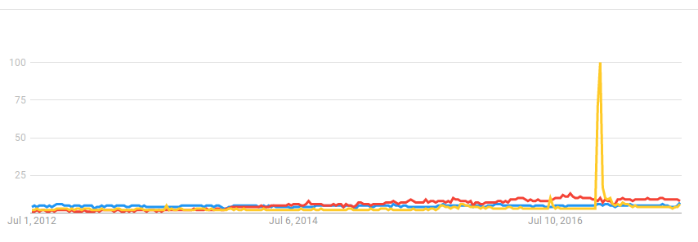

2. Multiple Usages

The safety pin, broadly, is a symbol of resilience and resourcefulness. A large safety pin is used as a kilt pin in less formal settings. Many generations of diapers were held together with safety pin. In the Ukraine, safety pins are fastened to the inside of a child’s clothing to ward off evil spirits. In parts of Mexico, a safety pin placed as close as possible to a pregnant woman's belly is said to protect the fetus from loss and disease.In parts of Europe finding a safety pin is good luck, and a portent of good fortune. It was and is closely associated with punk fashion starting in the 1970s. Knitters use safety pins as stitch markers. A wedding planner's emergency kit always includes a stash of safety pins -- the safety pin is a symbol of preparedness. A first aid kit isn't complete without a safety pin for splinters and a match to sterilize it with. We use safety pins to hold clothes together in an emergency, to attach amulets, charms and patches, to keep a bodice from falling open.
 In running and cycling, a safety pin indicates competition: even at the most elite levels of running competition, a runner's number is fastened to their uniform with a safety pin.



C. Image Distinctiveness
The SAFETY PIN is distinct and unlikely to be confused with any existing emoji.

D. Completeness
There is no where in the world where humans do not sew, whether for function (we need shoes, clothing, bedding) or as a creative outlet. Ravelery.com, a social network for fiber arts has 7 Million member. Burda, a sewing magazine and social network, has over half million registered users and hosts in-person clubs in a dozen countries. And yet there are no emoji that reflect the basic tools required to create and repair textiles.

Moreover, in combination with the ROUND PUSHPIN, PUSHPIN and PAPERCLIP, the SAFETY PIN completes the set of markers and fasteners.

E. Frequently Requested
Sewing and Knitting are consistently among the top emoji requests. See: 2016 and 2017. The safety pin is an important contribution to the "Sewing" category. Nearly 5 million Instagram posts use the #sewing hashtag and just shy of 800 thousand are tagged #quilting.
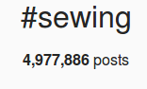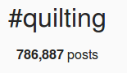

Selection Factors Exclusion

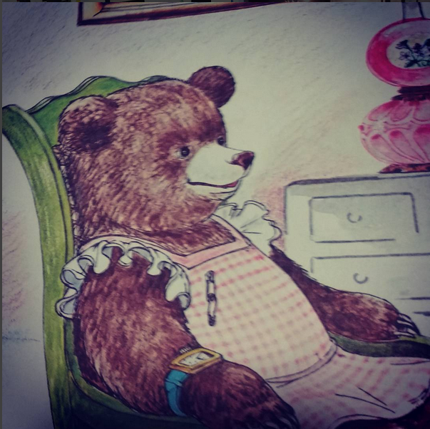
F. Overly Specific
See multiple usages: the safety pin itself is a hugely versatile object which can serve countless literal (fasten clothing together) and figurative (preparedness, resourcefulness, resilience) meanings.

G. Open Ended
The safety pin is not open ended. Visually, it is difficult to mistake a safety pin for anything but a larger or smaller safety pin.

H. Already Representable
The 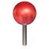 and 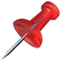 pushpin and map pin options are both forms of pin, but they are distinct from the self closing safety pin. The 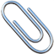paperclip emojis are often used to indicate "holding things together" even when those things would be better held by a safety pin.

I. Logos, brands, UI icons, signage, specific people, deities
A search of the WIPO Trademark Database for logos with "Image Class: VC.09.05.09" (or "safety pin") turns up two hundred different logos that incorporate a safety pin. It is widely used as a design element, but the design itself has been public domain since the 1849 patent expired.

The image we are submitting does not have any significance that would make it
unsuitable for encoding as a character. There are no copyright, religious, or issues that
reference anyone historic or living.

J. Transient
The design of the safety pin has changed very little since the ancient Roman fibula and almost not at all in the 168 years since Hunt's patent. There is no reason to think that it is going away.

K. Faulty Comparison
The safety pin is not represented in the current character set.

Sort location
(Proposed sort location for the emoji in Emoji Ordering)

- Object-textiles, after tool and before medical

Other Information

Author Bios(optional)
Amberley Romo (amberleyjohanna@gmail.com) is a software developer and avid knitter. Amberley grew up (and currently lives in) Texas, and has been very involved in the fiber arts communities of both Washington, DC and Austin, TX. She is passionate about knitting as a meditative practice, and community activity.

Amanda Hickman (amanda@velociraptor.info) runs a fellowship program that helps creative technologists collaborate with journalists on storytelling and audience engagement projects. She has been sewing since she was six years old, and cherishes the independence afforded by mending, altering and making her own clothes. She is currently using safety pins to keep a coat pocket from getting worse before she mends it, and to hold a patch in place while she mends her daughter's jeans.

Character Properties
The other character properties are suggested to be defined as follows.
General Category:
Canonical Combining Class:
Bidirectional Class:
Decomposition Type:
Decomposition Mapping:
Numeric Type:
Numeric Value:
Bidirectional Mirrored:
Name:
ISO Comment:
Simple Uppercase Mapping:
Simple Lowercase Mapping:
Simple Titlecase Mapping:

https://www.google.com/patents/US6281#v=onepage&q&f=false
https://www.penn.museum/sites/expedition/ancient-safety-pins/
https://www.alibaba.com/product-detail/hot-selling-silver-color-safety-pin_60335791647.html?s=p
https://anydayguide.com/calendar/459
https://unfold-yoga.com/2017/04/10/safety-pin-day/
https://en.wikipedia.org/wiki/Kilt_pin#cite_ref-four_4-1
https://www.theatlantic.com/technology/archive/2016/11/three-millennia-of-safety-pins/507629/
http://museumofeverydaylife.org/exhibitions-collections/current-exhibitions/a-visual-history-of-the-safety-pin
https://www.rollingstone.com/music/pictures/inside-the-mets-new-exhibit-punk-chaos-to-couture-20130507/pin-it-down-0787285
http://www.burdastyle.com/statics/about
http://blog.emojipedia.org/top-emoji-requests-2016/
http://blog.emojipedia.org/top-emoji-requests-2017/
http://www.wipo.int/branddb/en/

